UART implementering på DevKit8000

## Redmine WIKI - DevKit8000

<https://redmine.iha.dk/devs/projects/devkit8000/wiki/Addon_board_cpld#External-Serial-Interface-Routing-Register>

**External Serial Interface Routing Register**The I2C/SPI header (J9) can be configured for different serial Interfaces.

|  |  |  |  |  |  |  |  |  |
| --- | --- | --- | --- | --- | --- | --- | --- | --- |
|  | **External Serial Interface Routing Register** | | | | | | | |
| **BIT** | 7 | 6 | 5 | 4 | 3 | 2 | 1 | 0 |
| **Field** | Reserved | | | I2C | Reserved | | SPI | |
| **Reset** | 0x00 | | | | | | | |
| **R/W** | W | | | | | | | |
| **Addr** | 0x04 | | | | | | | |
| **File** | /sys/class/cplddrv/cpld/ext_serial_if_route_reg | | | | | | | |

SPI: External SPI/UART Routing

* 0x0: SPI1 Monitoring Mode (both MISO and SOMI are outputted)
* 0x1: SPI1 Slave Mode (SOMI is an input). Both CS0 and CS3 are routed to the header (J9).
* 0x2: UART2 Mode
* 0x3: Combo mode, SPI1 slave (CS0 or CS3 depending on SPI1 routing reg, CS0 has highest priority) + UART2 RxD/TxD. Use the "SPI1 Routing Register" in conjunction with this configuration

I2C: External I2C Routing

* 0: I2C Monitoring Mode (SDA is only an output)
* 1: I2C Slave Mode (SDA is bidirectional)

NOTE! Slave mode requires and external pull-up resistor on SDA, or the internal I2C bus will block due to the undefined value at the SDA pin.

Depending on the mode selected, the pin-out of the I2C/SPI/UARTheader (J9) becomes:

|  |  |  |  |  |  |  |  |  |  |
| --- | --- | --- | --- | --- | --- | --- | --- | --- | --- |
| **SPI/UART Interface Connections** | | | | | | | | | |
| **Header J9** | | **SPI1 Monitor** | | **SPI1 Slave** | | **UART** | | **Combo** | |
| Pin | Name | Signal | I/O | Signal | I/O | Signal | I/O | Signal | I/O |
| 1 | BSP1_DX | SIMO | out | SIMO | out | RTS | out | SIMO | out |
| 2 | BSP1_DR | SOMI | out | SOMI | in |  |  | SOMI | in |
| 3 | BSP1_FSX | CS0 | out | CS0 | out |  |  | CS0/3 | out |
| 4 | BSP1_FSR | CS3 | out | CS3 | out | TXD | out | TXD | out |
| 5 | BSP1_CLKX | CLK | out | CLK | out | CTS | in | CLK | out |
| 6 | BSP1_CLKR |  |  |  |  | RXD | in | RXD | in |

The I2C routing settings results in the following interface on header J9:

|  |  |  |  |  |  |  |  |  |
| --- | --- | --- | --- | --- | --- | --- | --- | --- |
|  | **I2C Interface Connections** | | | | | | | |
| **Header J9** | | **I2C Monitor** | | **I2C Slave** | |  |  |  |
| Pin | Name | Signal | I/O | Signal | I/O |  |  |  |
| 9 | IIC3_SDA | SDA | out | SDA | bidir |  |  |  |
| 11 | IIC3_SCL | SCL | out | SCL | in |  |  |  |

<https://redmine.iha.dk/devs/projects/devkit8000/wiki/AddonInterfaces#Add-on-Board-Interfaces>

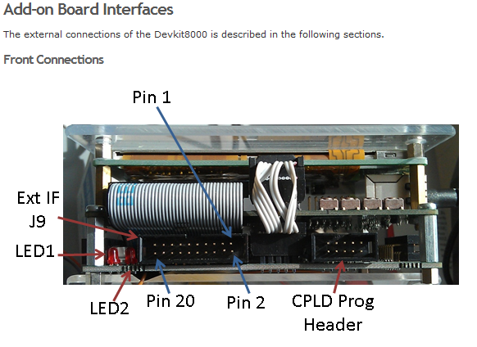

**SPI / I2C (J9)**

Connects to the OMAP’s IIC3 & SPI1. Can only be used for monitoring the busses!  
Voltage levels: 3.3 V  
20-Pin Header, 2.54mm

|  |  |  |  |
| --- | --- | --- | --- |
| **Pin** | Name | OMAP IO | Direction |
| **1** | SPI1_SIMO | SPI1_SIMO | OUT |
| **2** | SPI1_SOMI | SPI1_SOMI | OUT |
| **3** | SPI1_CS0 | SPI1_CS0 | OUT |
| **4** | SPI1_CS3 | SPI1_CS3 | OUT |
| **5** | SPI1_CLK | SPI1_CLK | OUT |
| **6** |  |  |  |
| **7** | GND |  |  |
| **8** |  |  |  |
| **9** | IIC3_SDA | IIC3_SDA | OUT |
| **10** |  |  |  |
| **11** | IIC3_SCL | IIC3_SDA | OUT |
| **12** |  |  |  |
| **13** | GND |  |  |
| **14** | GND |  |  |
| **15** |  |  |  |
| **16** | +5V |  |  |
| **17** | +3.3V |  |  |
| **18** |  |  |  |
| **19** | GND |  |  |
| **20** | GND |  |  |

## DevKit8000 Datablad oversigt

### Registre der skal sættes?

Side 340 i PDF DevKit8000 datasheet

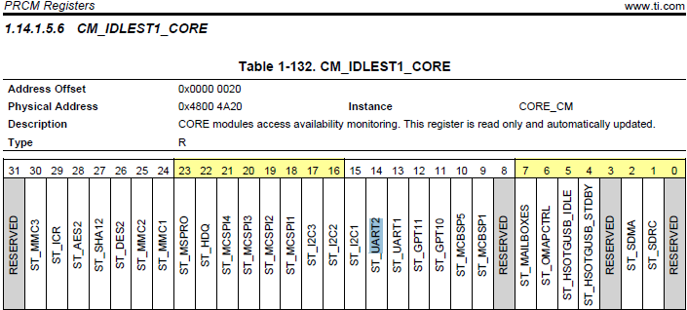



Side 451 i PDF DevKit8000 datasheet

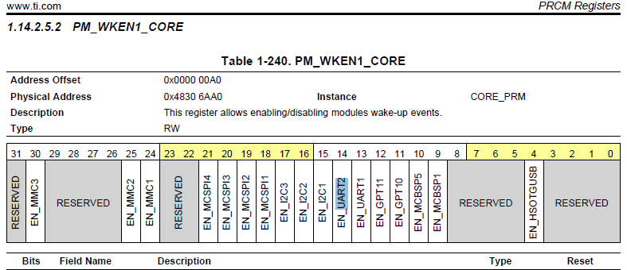

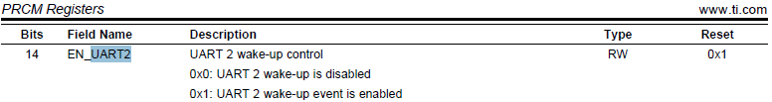

Side 734 i PDF DevKit8000 datasheet

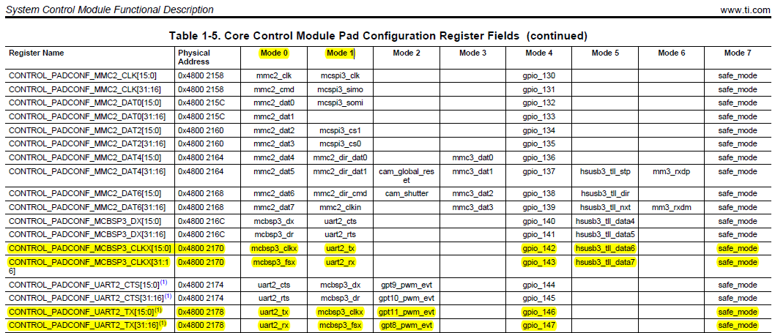

Side 738 i PDF DevKit8000 datasheet

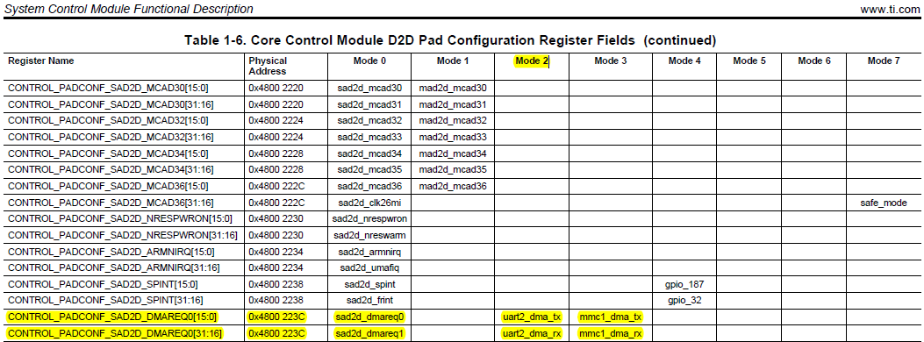

Side 1076 i DevKit8000 datasheet

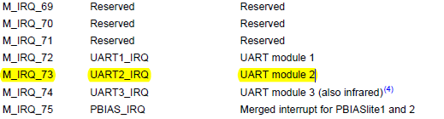

### Gennemgang af opsætningen

Side 2523 i DevKit8000 datasheet